Product Inventory Management System
TEAM:
Team Leader: B.C. Bhavana
Team Members: J.Sandhya
G. Udaya Banu
Charuku Archana
S.Divyasri.
Project Overview:
The Product Inventory Management System is a backend-based web application built using Node.js, Express.js, and MongoDB. It provides a reliable and secure platform for managing product information through RESTful APIs.
The application allows users to register and log in securely. After authentication, users can access protected routes using JWT (JSON Web Token) authentication, which ensures that only verified users can perform actions within the system.
The system includes complete CRUD operations, enabling users to create new product entries, view their stored products, modify details such as product price or quantity, and remove products when necessary. This design helps maintain an organized and efficient inventory management process.

Main Goals:
• Implement secure authentication and authorization using JWT.
• Provide effective product management through RESTful CRUD APIs.
• Ensure data privacy, allowing users to manage only their own products.
• Develop a scalable backend architecture using Node.js, Express.js, and MongoDB.
• Maintain efficient API responses with validation and proper error handling.

Intended Users:
• Small shop owners who need to maintain their product inventory.
• Freelancers and independent sellers tracking items or services.
• Developers learning backend development and authentication concepts.
• Students working on academic projects related to backend or full-stack development.
• Anyone who requires a simple and secure backend platform to manage product data.

Development Steps:
• Create the backend project directory structure.
• Setup and configure the Express.js server.
• Connect the application with the MongoDB database.
• Build authentication APIs for user registration and login.
• Implement product management APIs with CRUD functionality.
• Use Thunder Client in VS Code to test all API endpoints.

Required Tools and Technologies:
Tool / Software | Usage
Node.js | Provides the runtime environment to execute backend JavaScript code
MongoDB | Used as the database to store and manage application data
npm | Handles installation and management of project dependencies
VS Code | Serves as the code editor and development workspace

Technical Skills Needed:
• Basic understanding of JavaScript ES6 syntax and features
• Knowledge of developing REST APIs using Node.js and Express.js
• Familiarity with MongoDB database and Mongoose for data modeling
• Understanding of JWT-based authentication for secure access
• Awareness of Express.js middleware and request–response flow

Project Visual:

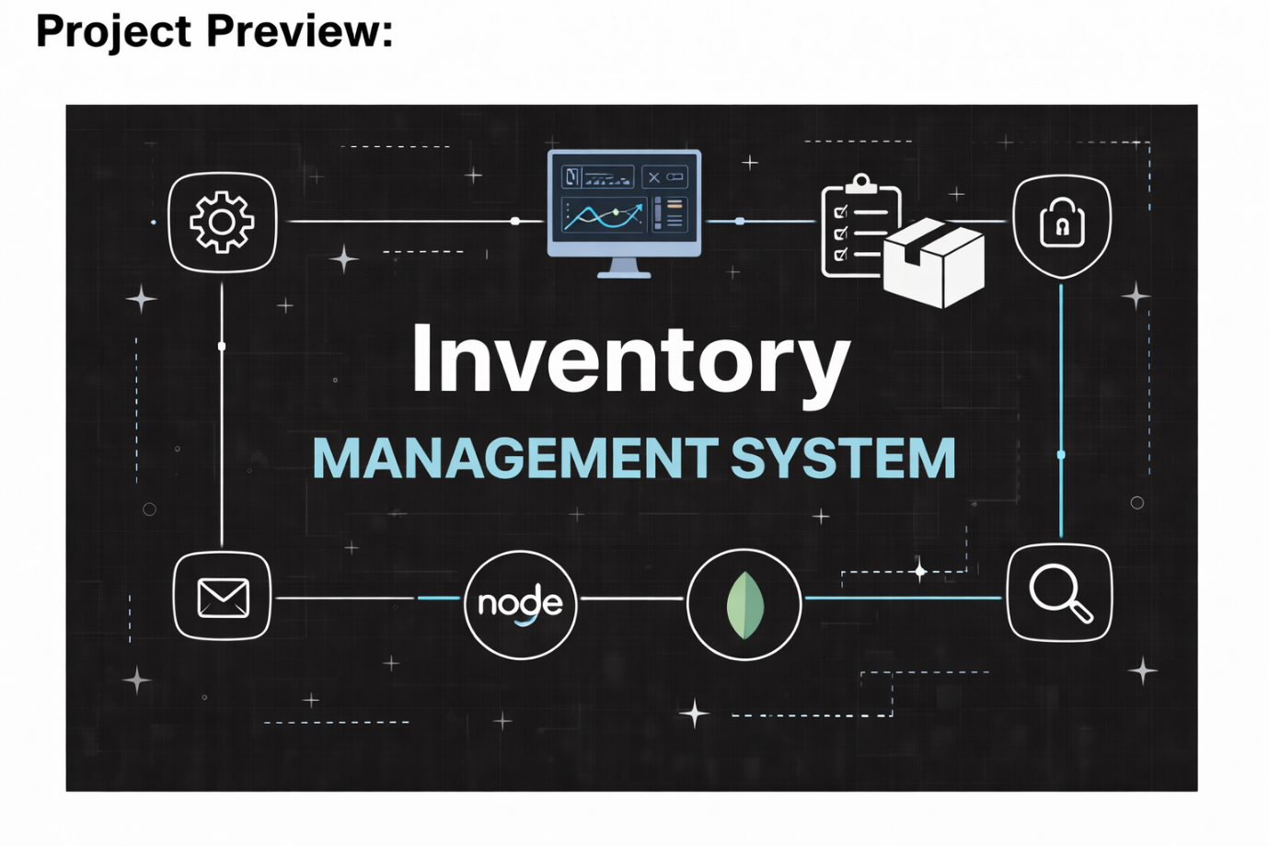

System Architecture Overview:
>A high-level diagram representing the three-layer backend architecture used in the project.
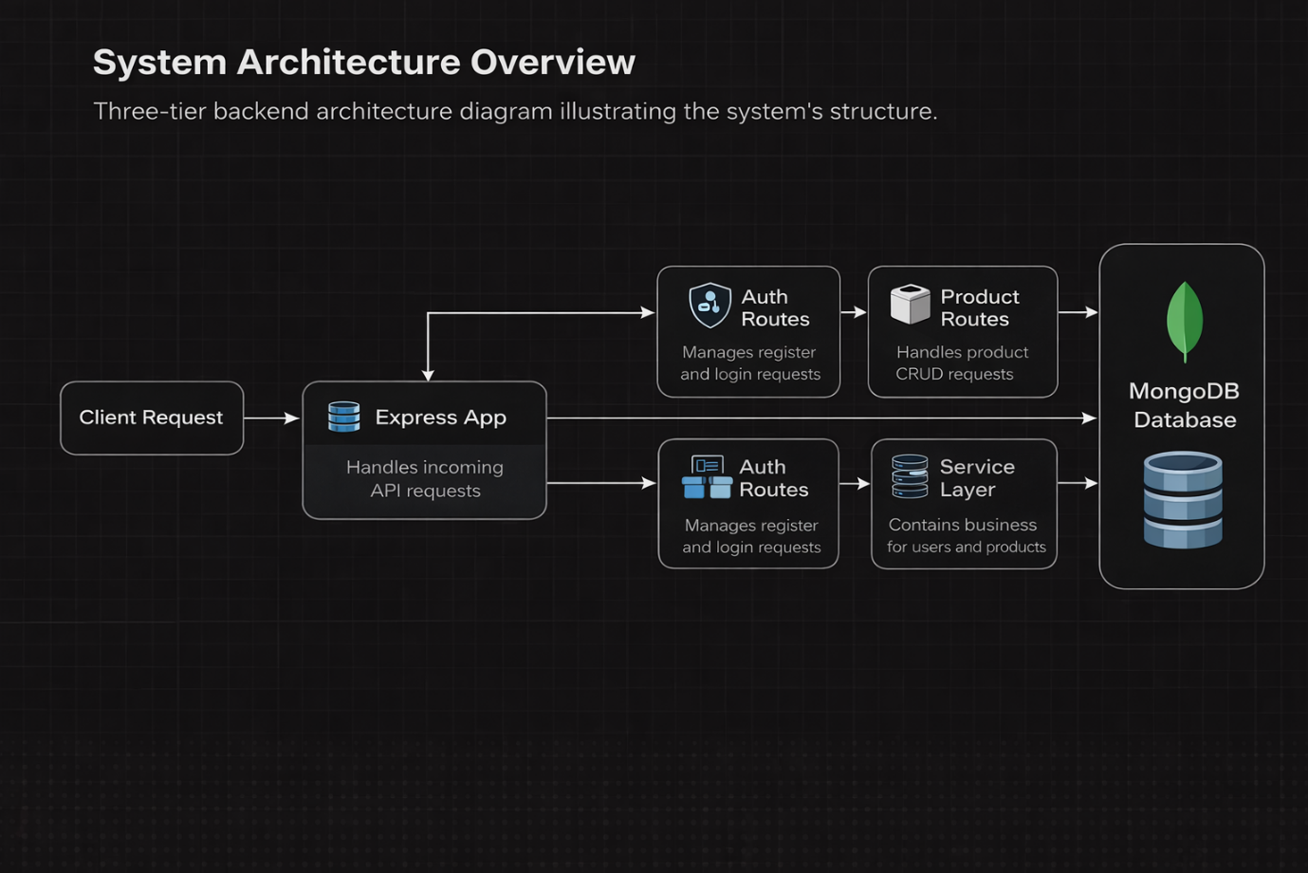

Server-Side Architecture (Node.js + Express):
• Built using REST API design principles.
• Implements JWT-based authentication middleware for secure access.
• Follows the MVC architecture (Models, Controllers, Routes).
• Includes request validation and proper error management.

Database Layer (MongoDB):
• Uses a NoSQL document-oriented database.
• Mongoose ODM is used to create and manage schemas.
• Maintains two main collections: Users and Products.
• Indexed fields are applied to improve query performance.

System Technical Structure:
Backend Structure (Node.js + Express)
• Controllers – Manage user authentication and product operations.
• Models – Define the structure of database documents.
• Routes – Provide API endpoints for authentication and product management.
• Middleware – Handles JWT verification and centralized error processing.
• Configuration – Manages environment variables and database setup.
Database Structure (MongoDB):
Users Collection
• _id
• username
• email address
• encrypted password
• createdAt / updatedAt timestamps

Products Collection:
• _id
• ownerId (reference to the user)
• productName
• productPrice
• stockQuantity
• productDescription
• createdAt / updatedAt timestamps

Data Relationship:
One User → Multiple Products
Indexing
• email (set as unique)
• ownerId
• productName

ER Diagram:
ER diagram showing User → Product relationship:

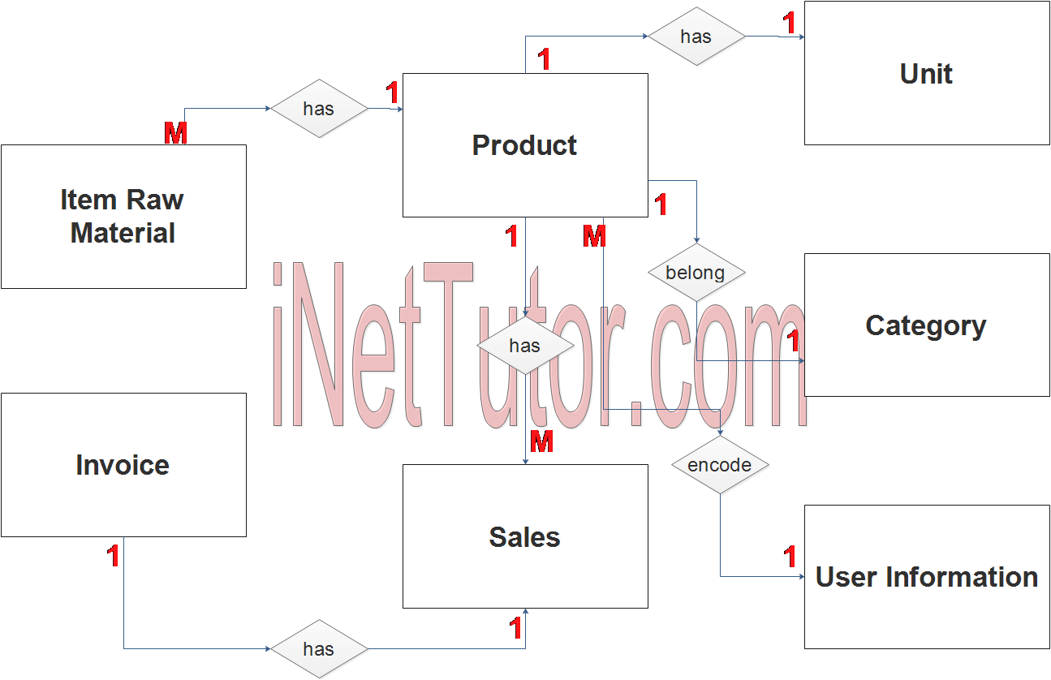

Main Functionalities:

S.No | Function | Details
1 | User Login & Registration | Secure authentication system using JWT tokens
2 | Product Management | Create, read, update, and remove product records
3 | Restricted Data Access | Each user can manage only their own product data
4 | Product Lookup | Ability to search products using their name
5 | Protected API Routes | Middleware ensures only authorized access to APIs

Roles and Responsibilities:
User
Account Registration: Create a new account by providing name, email, and password.
User Login: Access the system using registered email and password.
Add Product: Insert new product details including name, price, quantity, and description.
Modify Product: Edit or update existing product information.
Remove Product: Delete products from the inventory list.
Product Search: Find products using a keyword or product name.

User Workflow:
- The user sends a registration or login request to the server.
- After successful authentication, the backend generates a JWT token.
- The client includes this token in the Authorization header for protected requests.
- The middleware validates the token to ensure secure access.
- The controller handles the requested CRUD operation.
- MongoDB database stores or retrieves the product information.
- The API returns the appropriate response to the user.

Project Installation and Setup:

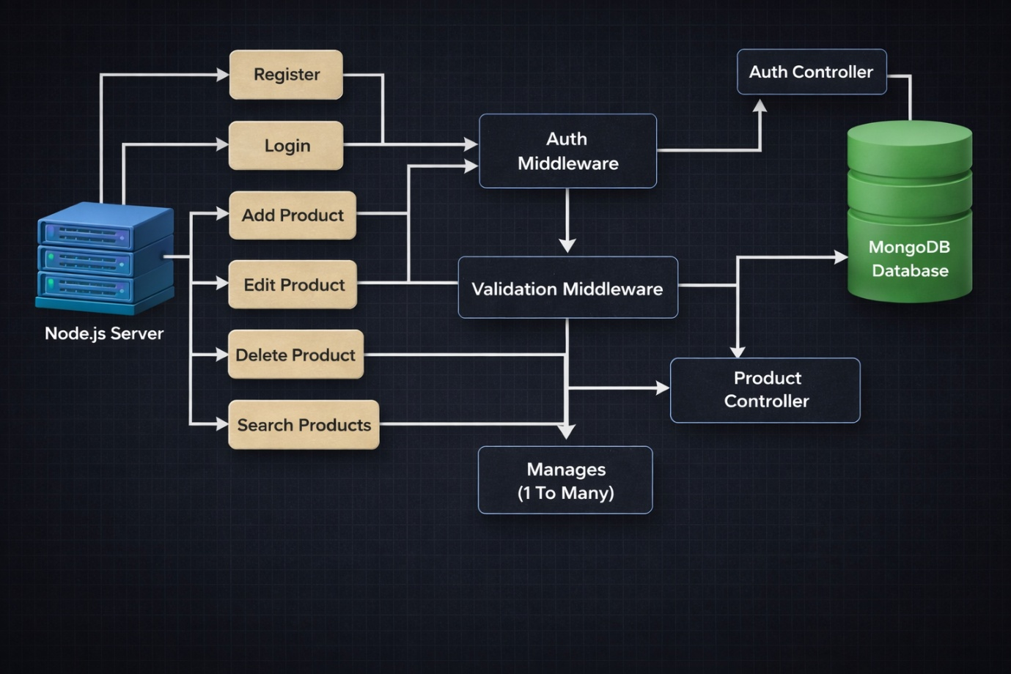

Project Directory Structure:

project-root
│
├── config
│ └── db.js
│
├── controllers
│ ├── auth.controller.js
│ └── product.controller.js
│
├── middleware
│ ├── auth.middleware.js
│ └── validation.middleware.js
│
├── models
│ ├── user.model.js
│ └── product.model.js
│
├── routes
│ ├── auth.routes.js
│ └── product.routes.js
│
├── utils
│ └── jwt.js
│
├── .env
├── package.json
└── server.js
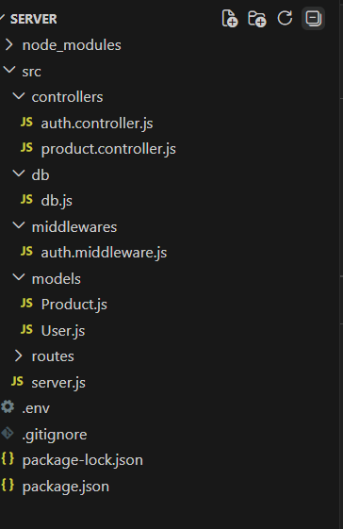

Project Initialization:
>Open the terminal inside the server directory and execute:
npm init -y
>This command automatically generates a package.json file which stores the project configuration and manages all required dependencies.

Installing Backend Dependencies:
>Install the necessary packages for building the backend application:
npm install express mongoose cors dotenv jsonwebtoken bcryptjs
>These libraries help handle server operations, database connectivity, authentication, and security.

Package Usage:
- express → Used to create the backend server
- mongoose → Used to connect with MongoDB
- cors → Allows frontend and backend communication
- dotenv → Manages environment variables
- jsonwebtoken → Used for user authentication
- bcryptjs → Used to encrypt passwords 🔐.

Create Environment File:
>Create a .env file inside the server root folder to store configuration details.
Example:
PORT=5000
MONGO_URI=your_mongodb_connection_string
JWT_SECRET=your_secret_key

Backend Development:

Setup Express Server:
Inside src/server.js, create the basic Express server.

// Import the express module
const express = require('express');
// Create an instance of an express app
const app = express();
// Define the port number
const PORT = 3000;
// Set up a basic route for the root URL
app.get('/', (req, res) => {
res.send('Hello World!'); // Send a response back to the client
});
// Start the server and listen on the specified port
app.listen(PORT, () => {
console.log(`Server is running on http://localhost:${PORT}`);
});

Create Controllers:
Inside: src/controllers/
Create:
auth.controller.js

// src/controllers/auth.controller.js
// Example login function
exports.login = (req, res) => {
// Authentication logic here (e.g., verify credentials)
res.send('Login successful');
};
// Example registration function
exports.register = (req, res) => {
// Registration logic here (e.g., create new user)
res.send('Registration successful');
};
// Example logout function
exports.logout = (req, res) => {
// Logout logic here (e.g., clear session/token)
res.send('Logout successful');
};

Auth Controller:
>The Auth Controller handles user authentication processes in the system. It manages user registration and login and provides secure access using JWT tokens.
Responsibilities:
- Create new user accounts
- Check and validate user input
- Encrypt passwords using bcrypt before saving
- Verify user credentials during login
- Generate JWT tokens for secure access
- Return proper success or error messages
Main Functions:
- Register User: Adds a new user after checking if the email already exists and hashing the password.
- Login User: Checks login details and provides a JWT token to access protected APIs. 🔐

product.controller.js

// Example function to create a new product in product.controller.js
exports.newProduct = async (req, res, next) => {
try {
// Interaction with the Product model (delegated logic)
const product = await Product.create(req.body);
// Sending the response
res.status(201).json({
success: true,
message: 'Product created successfully',
data: product,
});
} catch (error) {
// Handling errors
res.status(500).json({
success: false,
message: 'Failed to create product',
error: error.message,
});
}
};

Auth Middleware (protect):
The Auth Middleware is used to protect private routes by checking the JSON Web Token (JWT) in the request header. It looks for the Authorization header that begins with "Bearer " and verifies the token using the secret key.
If the token is valid, the user data is decoded and stored in req.user, allowing the request to continue to the next controller. If the token is not provided or invalid, the middleware sends a 401 Unauthorized response and blocks access to protected APIs. 🔒

const express = require('express');
// Import your authentication controller functions (e.g., login, register)
const AuthController = require('../controllers/authController');
const router = express.Router();
// Define the routes and link them to controller functions
router.post('/register', AuthController.register);
router.post('/login', AuthController.login);
router.get('/logout', AuthController.logout);
module.exports = router;

product.routes.js

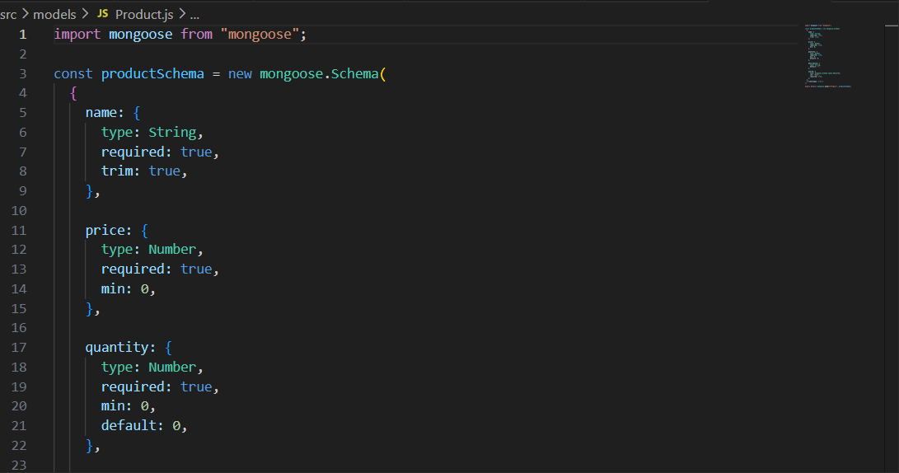

>Product routes manage all inventory-related operations such as creating, retrieving, updating, and deleting products. These routes are protected using authentication middleware to ensure only authorized users can access their own product data.
Connect Routes to Server:
>Import all routes into server.js
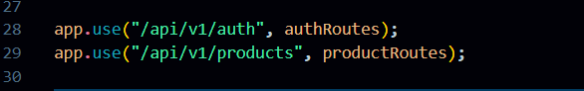

>These route settings link the authentication and product APIs with the main Express server using version-based endpoints. The /api/v1/auth route is used for user authentication actions, while /api/v1/products is responsible for handling product operations. This structure keeps the API organized and easy to scale.

Database Configuration and Setup:
- Create a MongoDB Atlas cluster
- Add the database connection string in the .env file
- Ensure the database is connected before testing APIs

Database Connection:
>Create a file inside src/db/db.js

Purpose:
>This file is used to connect the backend application to MongoDB using Mongoose.

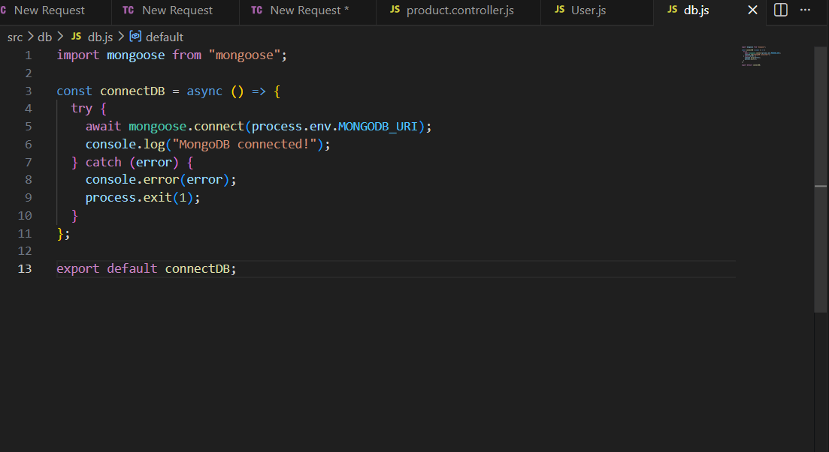

>The connectDB function connects the application to MongoDB using Mongoose and environment variables. It makes sure the server runs only after the database is connected successfully. If the connection fails, it displays an error message in the console.

Create Models:
Inside src/models/ create:
- User.js
- Product.js

User Model:
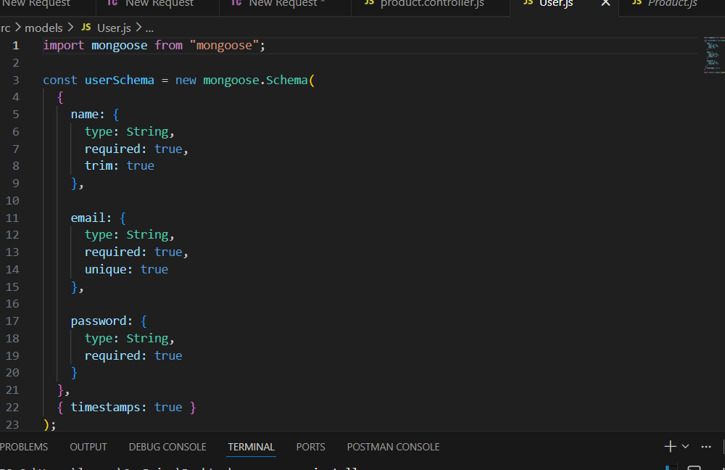

User Schema:
>The User schema describes how user information is stored in the database. It includes fields like name, email, and encrypted password. It also supports secure login and keeps timestamps to track when records are created and updated.
Product Model:


Project Execution:
Execution Steps
- Open terminal in server folder.
- Make sure you have a start script in the package.js file.
- Run:
npm start
4.Console should display:
Server running on PORT
Database Connected

API Testing :
>Register User:
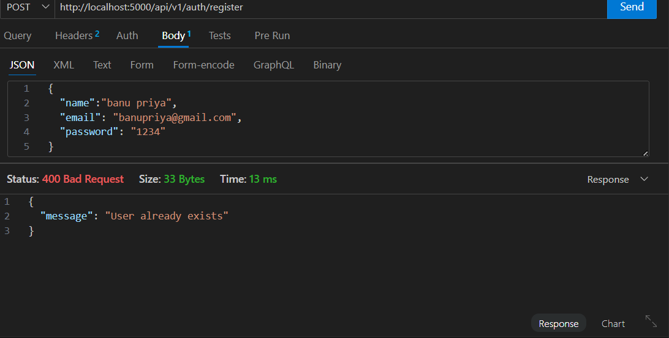
>The register function lets new users create an account by entering their details. The information is checked and the password is hashed for security before saving it to the database. It also ensures that each user is unique before allowing access to the system.

Login User:
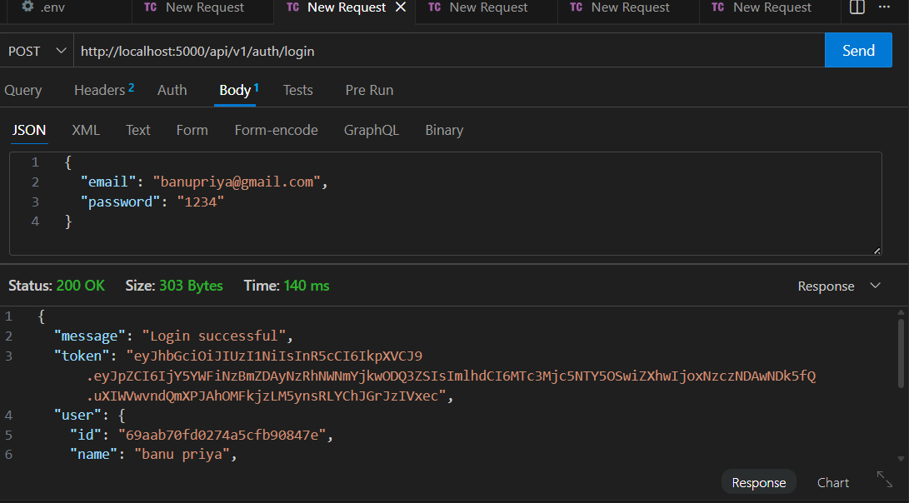
>The login function checks the user’s email and password. If the details are correct, it creates a JWT token. This token is then used to securely access protected routes.
Create Product:
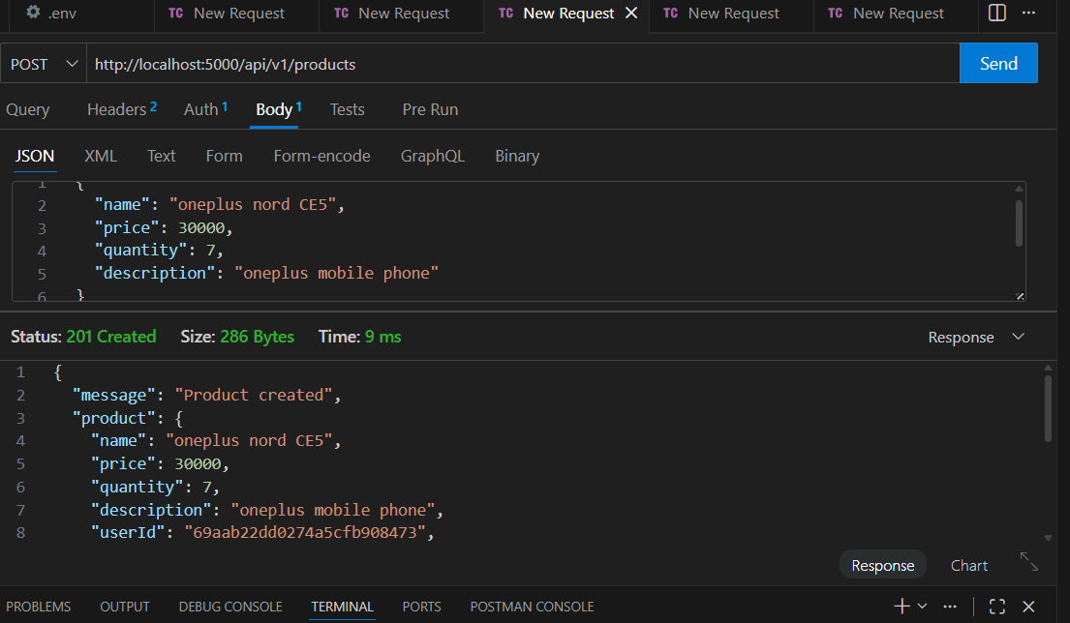

>Allows a logged-in user to create a new product by providing product details. The product is stored in the database along with the user’s ID to identify ownership.

Update Product:
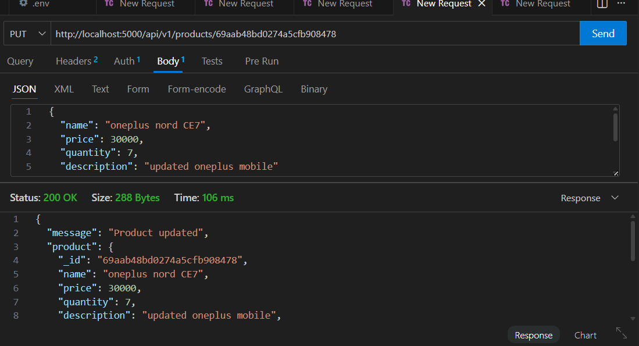
>Allows users to update existing product information such as product name, price, or quantity. The system checks whether the user owns the product before permitting any changes.
Delete Product:
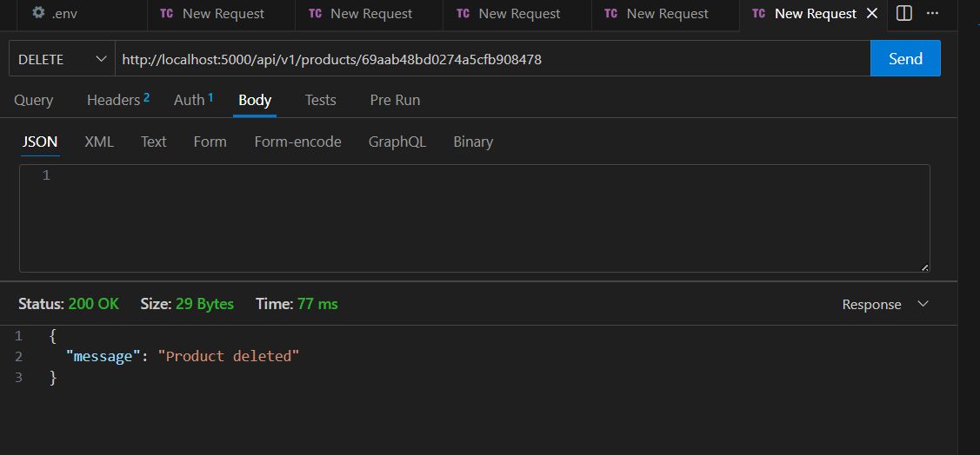

>Allows users to delete a product from their inventory permanently. The system verifies that only the product owner can perform the deletion.

Project Demo Video:
https://drive.google.com/file/d/15_cV-4ohMC8CWglX1XpTD1MDyQgWxkS4/view?usp=drive_link

